UNIT-III

ARCHITECTURE OF 8086:

The 8086 Microprocessor- Internal Architecture
The Intel 8086 is a 16-bit microprocessor intended to be used as the CPU in a microcomputer. The term “16-bit” means that its arithmetic logic unit, internal registers, and most of its instructions are designed to work 16-bit binary words. It has 16-bit data bus and 20-bit address bus.
Words will be stored in two consecutive memory locations. If the first byte of a word is at an even address, the 8086 can read the entire word in one operation. If the first byte of the word is at an odd address, the 8086 will read the first byte in one operation, and the second byte in another operation.
Following figure shows the internal block diagram of 8086 microprocessor.
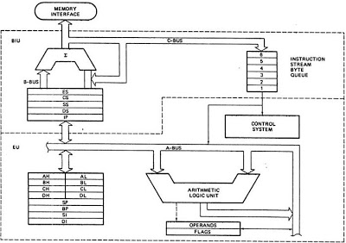
8086 Internal Block Diagram
The 8086 CPU is divided into two independent functional parts, the bus interface unit or BIU, and the execution unit or EU.

The Bus Interface Unit
The BIU handles all data and addresses on the buses for the execution unit such as it sends out addresses, fetches instructions from memory, reads data from ports and memory as well as writes data to ports and memory. In BIU there are so many functional groups or parts these are as follows.

Instruction Queue
To increase the execution speed, BIU fetches as many as six instruction bytes ahead to time from memory. The pre fetched instruction bytes are held for the EU in a first in first out group of registers called a instruction queue. When the EU is ready for its next instruction, it simply reads the instruction from this instruction queue. This is much faster than sending out an address to the system memory and to send back the next instruction byte. Fetching the next instruction while the current instruction executes is called pipelining.

Segment Registers
The BIU contains four 16-bit segment registers. They are: the extra segment (ES) register, the code segment (CS) registers, the data segment (DS) registers, and the stack segment (SS) registers. These segment registers are used to hold the upper 16 bits of the starting address for each of the segments. The part of a segment starting address stored in a segment register is often
called the segment base.
1. Code Segment (CS): The CS register is used for addressing a memory location in the Code Segment of the memory, where the executable program is stored.
2. Data Segment (DS): The DS contains most data used by program. Data are accessed in the
Data Segment by an offset address or the content of other register that holds the offset address.
3. Stack Segment (SS): SS defined a section of memory to store addresses and data while a subprogram executes.
4. Extra Segment (ES): ES is additional data segment that is used by some of the string to hold the extra destination data.

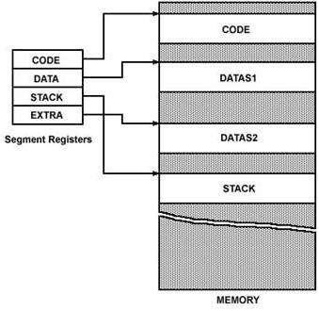
8086 Memory Segment

Instruction Pointer (IP)
In the BIU, the next register, below the segment register is instruction pointer. The instruction pointer (IP) holds the 16-bit address of the next code byte within this code segment.

The Execution Unit
The execution unit (EU) tells the BIU where to fetch instructions or data from, decodes instructions and executes instructions.
The functional parts of the execution unit are control circuitry or system, instruction decoder, and Arithmetic logic unit (ALU).
Control circuitry to perform various internal operations. A decoder in the EU translates instructions fetched from memory to generate different internal or external control signals that required performing the operation. The EU has a 16-bit ALU, which can perform arithmetic operations such as add, subtract etc. and logical operations such as AND, OR, XOR, increment, decrement etc.

Flag Register
A 16-bit flag register is a flip-flop which indicates some condition produced by the execution of an instruction or controls certain operations of the EU. They are modified automatically by CPU after mathematical operations. It has 9 flags and they are divided into two categories:
1.ConditionalFlags
2. Control Flags

Conditional Flags
Conditional flags represent result of last arithmetic or logical instructions.
· Carry Flag (CF): This flag will be set to one if the arithmetic operation produces the carry in MSB position. It is also used in multiple-precision arithmetic.
· Auxiliary Flag (AF): If an operation performed in ALU generates a carry/barrow from lower nibble (i.e. D0 – D3) to upper nibble (i.e. D4 – D7), the AF flag is set i.e. carry given by D3 bit to D4 is AF flag. This is not a general-purpose flag; it is used internally by the processor to perform Binary to BCD conversion.
· Parity Flag (PF): This flag is used to indicate the parity of result. If lower order 8-bits of the result contains even number of 1’s, the Parity Flag is set to one and for odd number of 1’s, the Parity Flag is reset i.e. zero.
· Zero Flag (ZF): It is set to one; if the result of arithmetic or logical operation is zero else it is reset.
· Sign Flag (SF): In sign magnitude format the sign of number is indicated by MSB bit. If the result of operation is negative, sign flag is set to one.
· Overflow Flag (OF): It occurs when signed numbers are added or subtracted. An OF indicates that the result has exceeded the capacity of machine.
Control Flags
Control flags are intentionally set or reset to control certain operations of the processor with specific instructions put in the program from the user. Control
flags are as follows:
1. Trap Flag (TP): It is used for single step control. It allows user to execute one instruction of a program at a time for debugging. When trap flag is set, program can be run in single step mode.
2. Interrupt Flag (IF): It is an interrupt enable/disable flag, i.e. used to allow/prohibit the interruption of a program. If it is set, the maskable interrupt is enabled and if it is reset, the interrupt is disabled.
3. Direction Flag (DF): It is used in string operation. If it is set, string bytes are accessed from higher memory address to lower memory address. When it is reset, the string bytes are accessed from lower memory address to higher memory address.
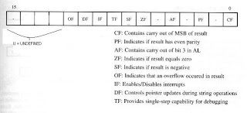
8086 Flag Register Format

General Purpose Registers
The EU has eight general purpose registers labeled AH, AL, BH, BL, CH, CL, DH, and DL. These registers can be used individually for temporary storage of 8-bit data. The AL register is also called the accumulator. Certain pairs of these general purpose registers can be used together to store 16-bit data. The valid register pairs are AH and AL, BH and BL, CH and CL and DH and DL. These register pairs is referred to the AX, BX, CX, and DX resp.
1. AX Register: For 16-bit operations, AX is called the accumulator register that stores operands for arithmetic operations.
2. BX Register: This register is mainly used as a base register. It holds the starting base location of a memory region within a data segment.
3. CX Register: It is defined as a counter. It is primarily used in loop instruction to store loop counter.
4. DX Register: DX register is used to contain I/O port address for I/O instruction.

Stack Pointer Register
The stack pointer (SP) register contains the 16-bit offset from the start of the segment to the memory location where a word was most recently stored on the stack. The memory location where a word was most recently stored is called the top of stack.
Other Pointer and Index Registers
The EU also contains a 16-bit source index (SI) register, base pointer (BP) registers, and Destination Index (DI) registers. These three registers can be mainly used for temporary storage of 16-bit data just like a general purpose registers.

PIN DIAGRAM OF 8086:
8086 was the first 16-bit microprocessor available in 40-pin DIP (Dual Inline Package) chip. Let us now discuss in detail the pin configuration of a 8086 Microprocessor.

8086 Pin Diagram
Here is the pin diagram of 8086 microprocessor −
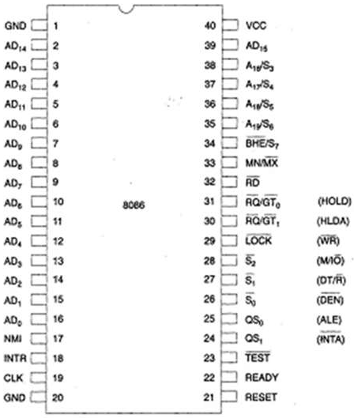
Let us now discuss the signals in detail −
Power supply and frequency signals
It uses 5V DC supply at V_{CC} pin 40, and uses ground at V_{SS} pin 1 and 20 for its operation.
Clock signal
Clock signal is provided through Pin-19. It provides timing to the processor for operations. Its frequency is different for different versions, i.e. 5MHz, 8MHz and 10MHz.
Address/data bus
AD0-AD15. These are 16 address/data bus. AD0-AD7 carries low order byte data and AD8AD15 carries higher order byte data. During the first clock cycle, it carries 16-bit address and after that it carries 16-bit data.
Address/status bus
A16-A19/S3-S6. These are the 4 address/status buses. During the first clock cycle, it carries 4-bit address and later it carries status signals.
S7/BHE
BHE stands for Bus High Enable. It is available at pin 34 and used to indicate the transfer of data using data bus D8-D15. This signal is low during the first clock cycle, thereafter it is active.
It is available at pin 32 and is used to read signal for Read operation.
Ready
It is available at pin 32. It is an acknowledgement signal from I/O devices that data is transferred. It is an active high signal. When it is high, it indicates that the device is ready to transfer data. When it is low, it indicates wait state.
RESET
It is available at pin 21 and is used to restart the execution. It causes the processor to immediately terminate its present activity. This signal is active high for the first 4 clock cycles to RESET the microprocessor.
INTR
It is available at pin 18. It is an interrupt request signal, which is sampled during the last clock cycle of each instruction to determine if the processor considered this as an interrupt or not.
NMI
It stands for non-maskable interrupt and is available at pin 17. It is an edge triggered input, which causes an interrupt request to the microprocessor.
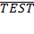This signal is like wait state and is available at pin 23. When this signal is high, then the processor has to wait for IDLE state, else the execution continues.
MN/ : It stands for Minimum/Maximum and is available at pin 33. It indicates what mode the processor is to operate in; when it is high, it works in the minimum mode and vice-aversa.
INTA : It is an interrupt acknowledgement signal and id available at pin 24. When the microprocessor receives this signal, it acknowledges the interrupt.
ALE: It stands for address enable latch and is available at pin 25. A positive pulse is generated each time the processor begins any operation. This signal indicates the availability of a valid address on the address/data lines.
DEN: It stands for Data Enable and is available at pin 26. It is used to enable Transreceiver 8286. The transreceiver is a device used to separate data from the address/data bus.
DT/R: It stands for Data Transmit/Receive signal and is available at pin 27. It decides the direction of data flow through the transreceiver. When it is high, data is transmitted out and vice-a-versa.
M/IO: This signal is used to distinguish between memory and I/O operations. When it is high, it indicates I/O operation and when it is low indicates the memory operation. It is available at pin 28.
WR: It stands for write signal and is available at pin 29. It is used to write the data into the memory or the output device depending on the status of M/IO signal.
HLDA: It stands for Hold Acknowledgement signal and is available at pin 30. This signal acknowledges the HOLD signal.
HOLD: This signal indicates to the processor that external devices are requesting to access the address/data buses. It is available at pin 31.
QS₁ and QS_{0:} These are queue status signals and are available at pin 24 and 25. These signals provide the status of instruction queue. Their conditions are shown in the following table −
QS₀ | QS₁ | Status
0 | 0 | No operation
0 | 1 | First byte of opcode from the queue
1 | 0 | Empty the queue
1 | 1 | Subsequent byte from the queue
S₀, S₁, S₂
These are the status signals that provide the status of operation, which is used by the Bus Controller 8288 to generate memory & I/O control signals. These are available at pin 26, 27, and 28.

Following is the table showing their status −
S₂ | S₁ | S₀ | Status
0 | 0 | 0 | Interrupt acknowledgement
0 | 0 | 1 | I/O Read
0 | 1 | 0 | I/O Write
0 | 1 | 1 | Halt
1 | 0 | 0 | Opcode fetch
1 | 0 | 1 | Memory read
1 | 1 | 0 | Memory write
1 | 1 | 1 | Passive
LOCK
When this signal is active, it indicates to the other processors not to ask the CPU to leave the system bus. It is activated using the LOCK prefix on any instruction and is available at pin 29.
RQ/GT₁ and RQ/GT₀
These are the Request/Grant signals used by the other processors requesting the CPU to release the system bus. When the signal is received by CPU, then it sends acknowledgment. RQ/GT₀ has a higher priority than RQ/GT₁.

INSTRUCTION SET OF 8086:
The 8086 microprocessor supports 8 types of instructions −
- Data Transfer Instructions
- Arithmetic Instructions
- Bit Manipulation Instructions
- String Instructions
- Program Execution Transfer Instructions (Branch & Loop Instructions)
- Processor Control Instructions
- Iteration Control Instructions
- Interrupt Instructions
Let us now discuss these instruction sets in detail.

Data Transfer Instructions
These instructions are used to transfer the data from the source operand to the destination operand. Following are the list of instructions under this group −

Instruction to transfer a word
- MOV − Used to copy the byte or word from the provided source to the provided destination.
- PPUSH − Used to put a word at the top of the stack.
- POP − Used to get a word from the top of the stack to the provided location.
- PUSHA − Used to put all the registers into the stack.
- POPA − Used to get words from the stack to all registers.
- XCHG − Used to exchange the data from two locations.
- XLAT − Used to translate a byte in AL using a table in the memory.

Instructions for input and output port transfer
- IN − Used to read a byte or word from the provided port to the accumulator.
- OUT − Used to send out a byte or word from the accumulator to the provided port.

Instructions to transfer the address
- LEA − Used to load the address of operand into the provided register.
- LDS − Used to load DS register and other provided register from the memory
- LES − Used to load ES register and other provided register from the memory.

Instructions to transfer flag registers
- LAHF − Used to load AH with the low byte of the flag register.
- SAHF − Used to store AH register to low byte of the flag register.
- PUSHF − Used to copy the flag register at the top of the stack.
- POPF − Used to copy a word at the top of the stack to the flag register.

Arithmetic Instructions
These instructions are used to perform arithmetic operations like addition, subtraction, multiplication, division, etc.
Following is the list of instructions under this group −

Instructions to perform addition
- ADD − Used to add the provided byte to byte/word to word.
- ADC − Used to add with carry.
- INC − Used to increment the provided byte/word by 1.
- AAA − Used to adjust ASCII after addition.
- DAA − Used to adjust the decimal after the addition/subtraction operation.

Instructions to perform subtraction
- SUB − Used to subtract the byte from byte/word from word.
- SBB − Used to perform subtraction with borrow.
- DEC − Used to decrement the provided byte/word by 1.
- NPG − Used to negate each bit of the provided byte/word and add 1/2’s complement.
- CMP − Used to compare 2 provided byte/word.
- AAS − Used to adjust ASCII codes after subtraction.
- DAS − Used to adjust decimal after subtraction.

Instruction to perform multiplication
- MUL − Used to multiply unsigned byte by byte/word by word.
- IMUL − Used to multiply signed byte by byte/word by word.
- AAM − Used to adjust ASCII codes after multiplication.

Instructions to perform division
- DIV − Used to divide the unsigned word by byte or unsigned double word by word.
- IDIV − Used to divide the signed word by byte or signed double word by word.
- AAD − Used to adjust ASCII codes after division.
- CBW − Used to fill the upper byte of the word with the copies of sign bit of the lower byte.
- CWD − Used to fill the upper word of the double word with the sign bit of the lower word.

Bit Manipulation Instructions
These instructions are used to perform operations where data bits are involved, i.e. operations like logical, shift, etc.
Following is the list of instructions under this group −

Instructions to perform logical operation
- NOT − Used to invert each bit of a byte or word.
- AND − Used for adding each bit in a byte/word with the corresponding bit in another byte/word.
- OR − Used to multiply each bit in a byte/word with the corresponding bit in another byte/word.
- XOR − Used to perform Exclusive-OR operation over each bit in a byte/word with the corresponding bit in another byte/word.
- TEST − Used to add operands to update flags, without affecting operands.

Instructions to perform shift operations
- SHL/SAL − Used to shift bits of a byte/word towards left and put zero(S) in LSBs.
- SHR − Used to shift bits of a byte/word towards the right and put zero(S) in MSBs.
- SAR − Used to shift bits of a byte/word towards the right and copy the old MSB into the new MSB.

Instructions to perform rotate operations
- ROL − Used to rotate bits of byte/word towards the left, i.e. MSB to LSB and to Carry Flag [CF].
- ROR − Used to rotate bits of byte/word towards the right, i.e. LSB to MSB and to Carry Flag [CF].
- RCR − Used to rotate bits of byte/word towards the right, i.e. LSB to CF and CF to MSB.
- RCL − Used to rotate bits of byte/word towards the left, i.e. MSB to CF and CF to LSB.

String Instructions
String is a group of bytes/words and their memory is always allocated in a sequential order.
Following is the list of instructions under this group −
- REP − Used to repeat the given instruction till CX ≠ 0.
- REPE/REPZ − Used to repeat the given instruction until CX = 0 or zero flag ZF = 1.
- REPNE/REPNZ − Used to repeat the given instruction until CX = 0 or zero flag ZF = 1.
- MOVS/MOVSB/MOVSW − Used to move the byte/word from one string to another.
- COMS/COMPSB/COMPSW − Used to compare two string bytes/words.
- INS/INSB/INSW − Used as an input string/byte/word from the I/O port to the provided memory location.
- OUTS/OUTSB/OUTSW − Used as an output string/byte/word from the provided memory location to the I/O port.
- SCAS/SCASB/SCASW − Used to scan a string and compare its byte with a byte in AL or string word with a word in AX.
- LODS/LODSB/LODSW − Used to store the string byte into AL or string word into AX.

Program Execution Transfer Instructions (Branch and Loop Instructions)
These instructions are used to transfer/branch the instructions during an execution. It includes the following instructions −

Instructions to transfer the instruction during an execution without any condition −
- CALL − Used to call a procedure and save their return address to the stack.
- RET − Used to return from the procedure to the main program.
- JMP − Used to jump to the provided address to proceed to the next instruction.
Instructions to transfer the instruction during an execution with some conditions −
- JA/JNBE − Used to jump if above/not below/equal instruction satisfies.
- JAE/JNB − Used to jump if above/not below instruction satisfies.
- JBE/JNA − Used to jump if below/equal/ not above instruction satisfies.
- JC − Used to jump if carry flag CF = 1
- JE/JZ − Used to jump if equal/zero flag ZF = 1
- JG/JNLE − Used to jump if greater/not less than/equal instruction satisfies.
- JGE/JNL − Used to jump if greater than/equal/not less than instruction satisfies.
- JL/JNGE − Used to jump if less than/not greater than/equal instruction satisfies.
- JLE/JNG − Used to jump if less than/equal/if not greater than instruction satisfies.
- JNC − Used to jump if no carry flag (CF = 0)
- JNE/JNZ − Used to jump if not equal/zero flag ZF = 0
- JNO − Used to jump if no overflow flag OF = 0
- JNP/JPO − Used to jump if not parity/parity odd PF = 0
- JNS − Used to jump if not sign SF = 0
- JO − Used to jump if overflow flag OF = 1
- JP/JPE − Used to jump if parity/parity even PF = 1
- JS − Used to jump if sign flag SF = 1

Processor Control Instructions
These instructions are used to control the processor action by setting/resetting the flag values.
Following are the instructions under this group −
- STC − Used to set carry flag CF to 1
- CLC − Used to clear/reset carry flag CF to 0
- CMC − Used to put complement at the state of carry flag CF.
- STD − Used to set the direction flag DF to 1
- CLD − Used to clear/reset the direction flag DF to 0
- STI − Used to set the interrupt enable flag to 1, i.e., enable INTR input.
- CLI − Used to clear the interrupt enable flag to 0, i.e., disable INTR input.

Iteration Control Instructions
These instructions are used to execute the given instructions for number of times. Following is the list of instructions under this group −
- LOOP − Used to loop a group of instructions until the condition satisfies, i.e., CX = 0
- LOOPE/LOOPZ − Used to loop a group of instructions till it satisfies ZF = 1 & CX = 0
- LOOPNE/LOOPNZ − Used to loop a group of instructions till it satisfies ZF = 0 & CX = 0
- JCXZ − Used to jump to the provided address if CX = 0

Interrupt Instructions
These instructions are used to call the interrupt during program execution.
- INT − Used to interrupt the program during execution and calling service specified.
- INTO − Used to interrupt the program during execution if OF = 1
- IRET − Used to return from interrupt service to the main program

INTERRUPTS OF 8086:
Interrupt is the method of creating a temporary halt during program execution and allows peripheral devices to access the microprocessor. The microprocessor responds to that interrupt with an ISR (Interrupt Service Routine), which is a short program to instruct the microprocessor on how to handle the interrupt.
The following image shows the types of interrupts we have in a 8086 microprocessor −
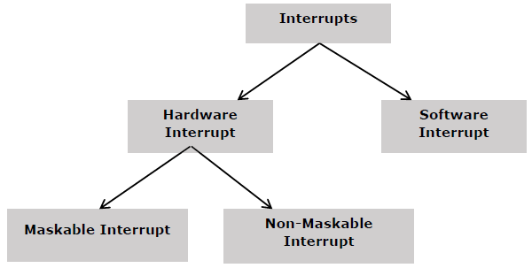

Hardware Interrupts
Hardware interrupt is caused by any peripheral device by sending a signal through a specified pin to the microprocessor.
The 8086 has two hardware interrupt pins, i.e. NMI and INTR. NMI is a non-maskable interrupt and INTR is a maskable interrupt having lower priority. One more interrupt pin associated is INTA called interrupt acknowledge.

NMI
It is a single non-maskable interrupt pin (NMI) having higher priority than the maskable interrupt request pin (INTR)and it is of type 2 interrupt.
When this interrupt is activated, these actions take place −
- Completes the current instruction that is in progress.
- Pushes the Flag register values on to the stack.
- Pushes the CS (code segment) value and IP (instruction pointer) value of the return address on to the stack.
- IP is loaded from the contents of the word location 00008H.
- CS is loaded from the contents of the next word location 0000AH.
- Interrupt flag and trap flag are reset to 0.

INTR
The INTR is a maskable interrupt because the microprocessor will be interrupted only if interrupts are enabled using set interrupt flag instruction. It should not be enabled using clear interrupt Flag instruction.
The INTR interrupt is activated by an I/O port. If the interrupt is enabled and NMI is disabled, then the microprocessor first completes the current execution and sends ‘0’ on INTA pin twice. The first ‘0’ means INTA informs the external device to get ready and during the second ‘0’ the microprocessor receives the 8 bit, say X, from the programmable interrupt controller.
These actions are taken by the microprocessor −
- First completes the current instruction.
- Activates INTA output and receives the interrupt type, say X.
- Flag register value, CS value of the return address and IP value of the return address are pushed on to the stack.
- IP value is loaded from the contents of word location X × 4
- CS is loaded from the contents of the next word location.
- Interrupt flag and trap flag is reset to 0

Software Interrupts
Some instructions are inserted at the desired position into the program to create interrupts. These interrupt instructions can be used to test the working of various interrupt handlers. It includes −

INT- Interrupt instruction with type number
It is 2-byte instruction. First byte provides the op-code and the second byte provides the interrupt type number. There are 256 interrupt types under this group.
Its execution includes the following steps −
- Flag register value is pushed on to the stack.
- CS value of the return address and IP value of the return address are pushed on to the stack.
- IP is loaded from the contents of the word location ‘type number’ × 4
- CS is loaded from the contents of the next word location.
- Interrupt Flag and Trap Flag are reset to 0
The starting address for type0 interrupt is 000000H, for type1 interrupt is 00004H similarly for type2 is 00008H and ……so on. The first five pointers are dedicated interrupt pointers. i.e. −
- TYPE 0 interrupt represents division by zero situation.
- TYPE 1 interrupt represents single-step execution during the debugging of a program.
- TYPE 2 interrupt represents non-maskable NMI interrupt.
- TYPE 3 interrupt represents break-point interrupt.
- TYPE 4 interrupt represents overflow interrupt.
The interrupts from Type 5 to Type 31 are reserved for other advanced microprocessors, and interrupts from 32 to Type 255 are available for hardware and software interrupts.

INT 3-Break Point Interrupt Instruction
It is a 1-byte instruction having op-code is CCH. These instructions are inserted into the program so that when the processor reaches there, then it stops the normal execution of program and follows the break-point procedure.
Its execution includes the following steps −
- Flag register value is pushed on to the stack.
- CS value of the return address and IP value of the return address are pushed on to the stack.
- IP is loaded from the contents of the word location 3×4 = 0000CH
- CS is loaded from the contents of the next word location.
- Interrupt Flag and Trap Flag are reset to 0

INTO - Interrupt on overflow instruction
It is a 1-byte instruction and their mnemonic INTO. The op-code for this instruction is CEH. As the name suggests it is a conditional interrupt instruction, i.e. it is active only when the overflow flag is set to 1 and branches to the interrupt handler whose interrupt type number is 4. If the overflow flag is reset then, the execution continues to the next instruction.
Its execution includes the following steps −
- Flag register values are pushed on to the stack.
- CS value of the return address and IP value of the return address are pushed on to the stack.
- IP is loaded from the contents of word location 4×4 = 00010H
- CS is loaded from the contents of the next word location.
- Interrupt flag and Trap flag are reset to 0

ADDRESSING MODES OF 8086:
The different ways in which a source operand is denoted in an instruction is known as addressing modes. There are 8 different addressing modes in 8086 programming −

Immediate addressing mode
The addressing mode in which the data operand is a part of the instruction itself is known as immediate addressing mode.

Example
MOV CX, 4929 H, ADD AX, 2387 H, MOV AL, FFH

Register addressing mode
It means that the register is the source of an operand for an instruction.

Example
MOV CX, AX ; copies the contents of the 16-bit AX register into
; the 16-bit CX register),
ADD BX, AX

Direct addressing mode
The addressing mode in which the effective address of the memory location is written directly in the instruction.

Example
MOV AX, [1592H], MOV AL, [0300H]

Register indirect addressing mode
This addressing mode allows data to be addressed at any memory location through an offset address held in any of the following registers: BP, BX, DI & SI.

Example
MOV AX, [BX] ; Suppose the register BX contains 4895H, then the contents
; 4895H are moved to AX
ADD CX, {BX}

Based addressing mode
In this addressing mode, the offset address of the operand is given by the sum of contents of the BX/BP registers and 8-bit/16-bit displacement.

Example
MOV DX, [BX+04], ADD CL, [BX+08]

Indexed addressing mode
In this addressing mode, the operands offset address is found by adding the contents of SI or DI register and 8-bit/16-bit displacements.

Example
MOV BX, [SI+16], ADD AL, [DI+16]

Based-index addressing mode
In this addressing mode, the offset address of the operand is computed by summing the base register to the contents of an Index register.

Example
ADD CX, [AX+SI], MOV AX, [AX+DI]

Based indexed with displacement mode
In this addressing mode, the operands offset is computed by adding the base register contents. An Index registers contents and 8 or 16-bit displacement.

Example
MOV AX, [BX+DI+08], ADD CX, [BX+SI+16]

Difference between MAX and MIN mode
Maximum mode | Minimum Mode
When MN/MX(bar) low 8086 is in maximum mode. | When MN/MX(bar) high 8086 is in minimum mode.
In maximum mode 8086 generates QS1,QS0,S0(bar),S1(bar),S2(bar), LOCK(bar),RQ(bar)/GT1,RQ(bar)/GT0 control signals. | In minimum mode 8086 generates INTA(bar), ALE, DEN(bar), DT/R(bar), M/IO(bar), HLDA,HOLD and WR(bar) control signals.
So clearly there are multiple processors in the system. | There is only one processor in the system minimum mode.
Whereas in maximum mode interfacing, master/slave and multiplexing and several such control signals are required. In maximum mode a bus controller is required to produce control signals. This bus controller produces MEMRDC, MEMWRC, IORDC, IOWRC, ALE, DEN, DT/R control signals. | In minimum mode no interfacing or master/slave signals is required. In minimum mode direct RD WR signals can be used. No bus controller required. A simple demultiplexer would do the job. of producing the control signals. This demultiplexer produces MEMRD, MEMWR, IORD, IOWR control signals.

Minimum Mode 8086 System
The microprocessor 8086 is operated in minimum mode by strapping its MN/MX pin to logic 1.In this mode, all the control signals are given out by the microprocessor chip itself. There is a single microprocessor in the minimum mode system. The remaining components in the system are latches, transreceivers , clock generator, memory and I/O devices. Latches are generally buffered output D-type f lip-f lops like 74LS373 or 8282. They are used for separating the valid address from the multiplexed address/data signals and are controlled by the ALE signal generated by 8086.
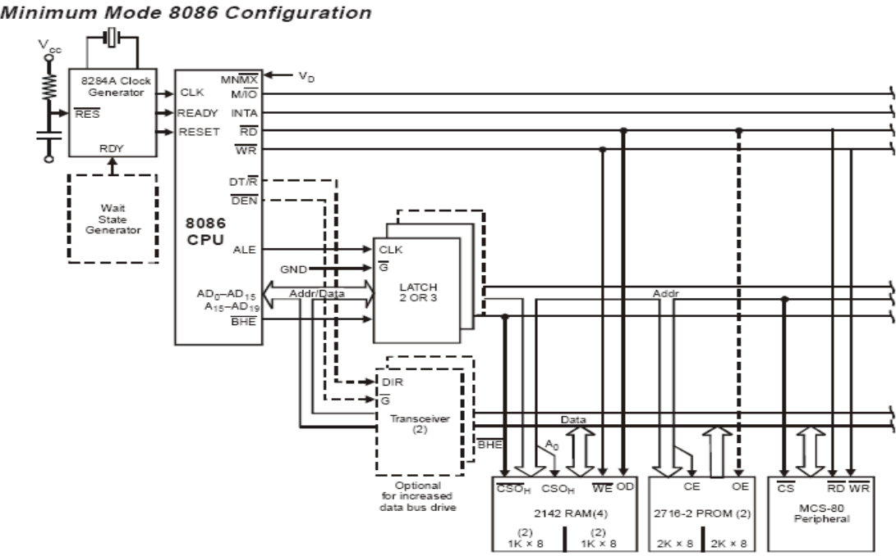
Transreceivers are the bidirectional buffers and some times they are called as data amplifiers. They are required to separate the valid data from the time multiplexed address/data signals. They are controlled by two signals namely, DEN and DT/R. The DEN signal indicates the direction of data, i.e. from or to the processor.
The system contains memory for the monitor and users program storage. Usually, EPROM are used for monitor storage, while RAM for users program storage. A system may contain I/O devices. The opcode fetch and read cycles are similar. Hence the timing diagram can be categorized in two parts, the first is the timing diagram for read cycle and the second is the timing diagram for write cycle. The read cycle begins in T1 with the assertion of address latch enable (ALE) signal and also M / IO signal. During the negative going edge of this signal, the valid address is latched on the local bus. The BHE and A0 signals address low, high or both bytes. From T1 to T4 , the M/IO signal indicates a memory or I/O Operation. At T2, the address is removed from the local bus and is sent to the output. The bus is then tristated. The read (RD) control signal is also activated in T2. The read (RD) signal causes the address device to enable its data bus drivers. After RD goes low, the valid data is available on the data bus. The addressed device will drive the READY line high. When the processor returns the read signal to high level, the addressed device will again tristate its bus drivers. A write cycle also begins with the assertion of ALE and the emission of the address. The M/IO signal is again asserted to indicate a memory or I/O operation. In T2, after sending the address in T1, the processor sends the data to be written to the addressed location. The data remains on the bus until middle of T4 state. The WR becomes active at the beginning of T2 (unlike RD is somewhat delayed in T2 to provide time for floating). The BHE and A0 signals are used to select the proper byte or bytes of memory or I/O word to be read or write. The M/IO, RD and WR signals indicate the type of data transfer as specified in table below.
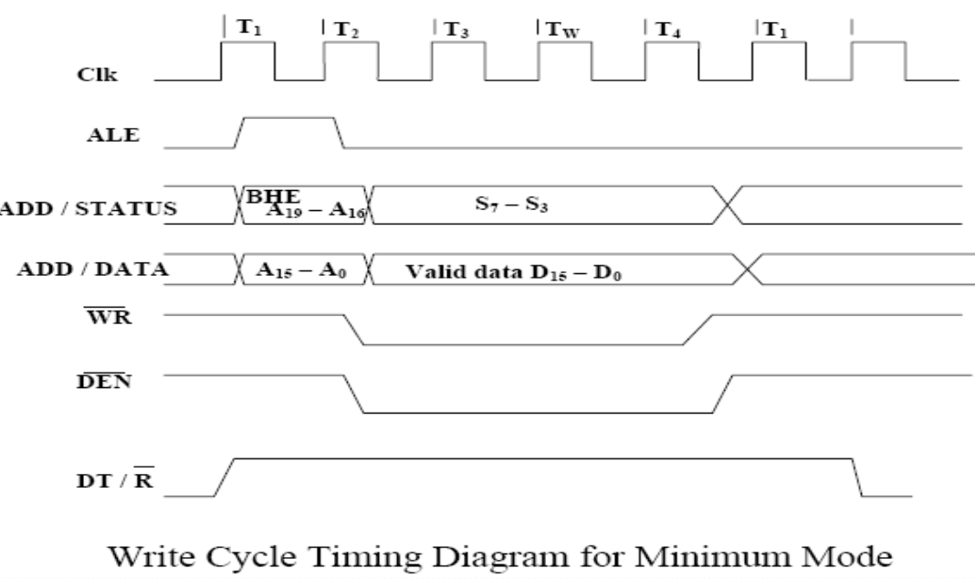

Hold Response sequence:

The HOLD pin is checked at leading edge of each clock pulse. If it is received active by the processor before T4 of the previous cycle or during T1 state of the current cycle, the CPU activates HLDA in the next clock cycle and for succeeding bus cycles, the bus will be given to another requesting master. The control of the bus is not regained by the processor until the requesting master does not drop the HOLD pin low.
When the request is dropped by the requesting master, the HLDA is dropped by the processor at the trailing edge of the next clock.

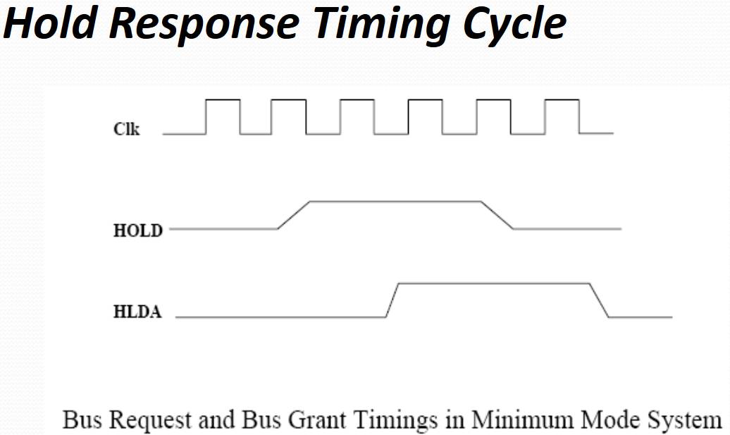

Maximum Mode 8086 System
In the maximum mode, the 8086 is operated by strapping the MN/MX pin to ground. In this mode, the processor derives the status signal S2, S1, S0.Another chip called bus controller derives the control signal using this status information . In the maximum mode, there may be more than one microprocessor in the system configuration. The components in the system are same as in the minimum mode system. The basic function of the bus controller chip IC8288, is to derive control signals like RD and WR ( for memory and I/O devices),DEN, DT/R, ALE etc. using the information by the processor on the status lines. The bus controller chip has input lines S2, S1, S0 and CLK. These inputs to 8288 are driven by CPU. It derives the outputs ALE, DEN, DT/R, MRDC, MWTC,AMWC, IORC, IOWC and AIOWC. The AEN, IOB and CEN pins are specially useful for multiprocessor systems.AEN and IOB are generally grounded. CEN pin is usually tied to +5V. The significance of the MCE/PDEN output depends upon the status of the IOB pin. INTA pin used to issue two interrupt acknowledge pulses to the interrupt controller or to an interrupting device. IORC, IOWC are I/O read command and I/O write command signals respectively . These signals enable an IO interface to read or write the data from or to the address port. The MRDC, MWTC are memory read command and memory write command signals respectively and may be used as memory read or write signals. All these command signals instructs the memory to accept or send data from or to the bus. Here the only difference between in timing diagram between minimum mode and maximum mode is the status signals used and the available control and advanced command signals.
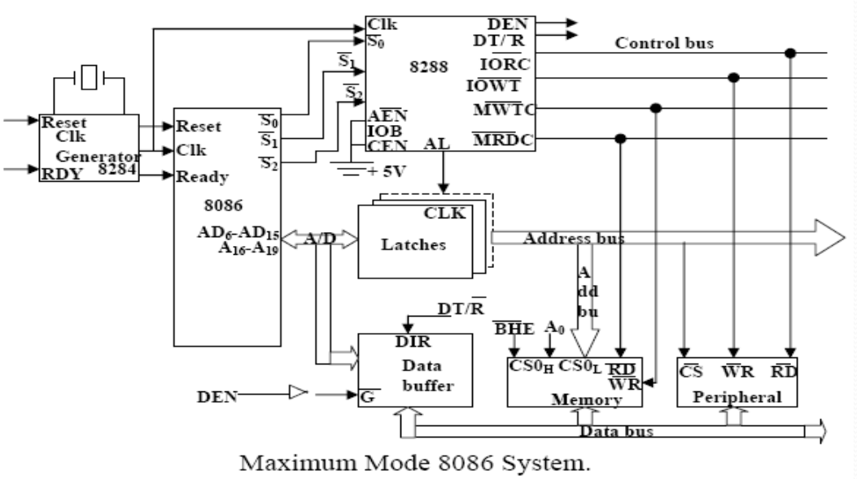

R0, S1, S2 are set at the beginning of bus cycle.8288 bus controller will output a pulse as on the ALE and apply a required signal to its DT / R pin during T1.
In T2, 8288 will set DEN=1 thus enabling transceivers, and for an input it will activate MRDC or IORC. These signals are activated until T4. For an output, the AMWC or AIOWC is activated from T2 to T4 and MWTC or IOWC is activated from T3 to T4.The status bit S0 to S2 remains active until T3 and become passive during T3 and T4. If reader input is not activated before T3, wait state will be inserted between T3 and T4.
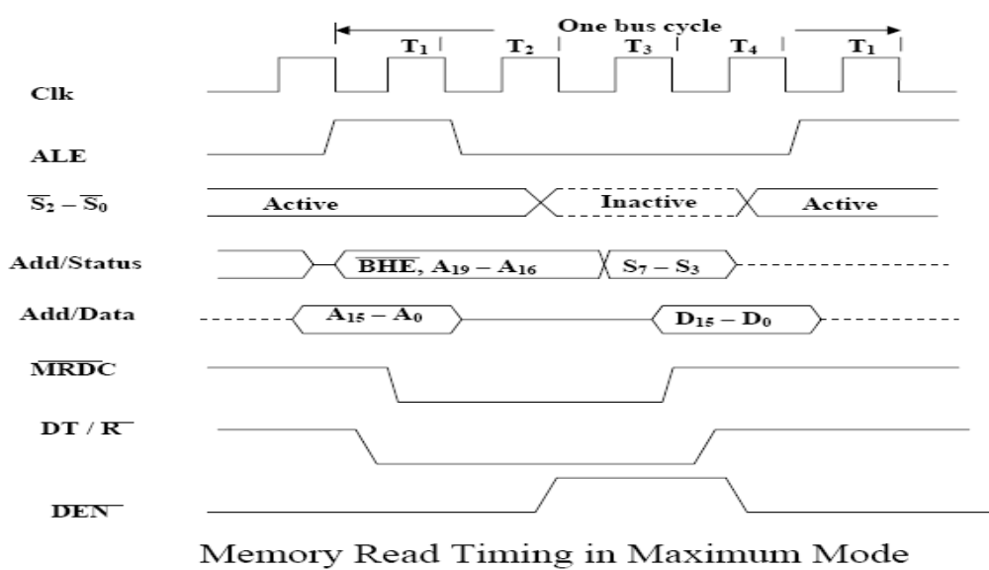
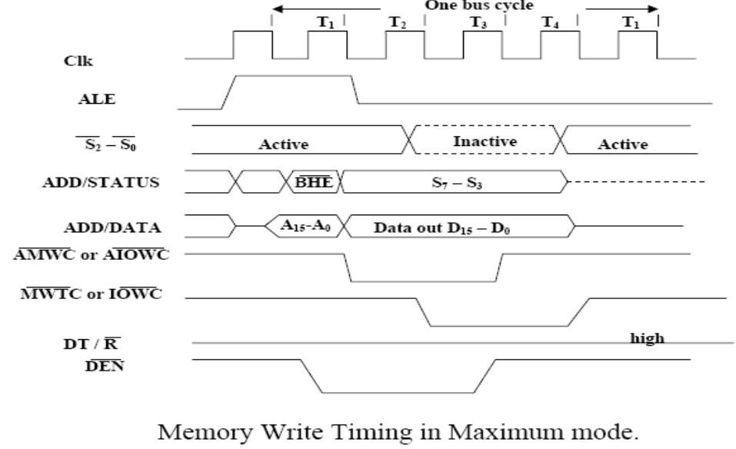

Assembler Directives of 8086 Microprocessor

INTRODUCTION:
Assembly languages are low-level languages for programming computers, microprocessors, microcontrollers, and other IC. They implement a symbolic representation of the numeric machine Codes and other constants needed to program a particular CPU architecture. This representation is usually defined by the hardware manufacturer, and is based on abbreviations that help the programmer to remember individual instructions, registers. An assembler directive is a statement to give direction to the assembler to perform task of the assembly process.
It control the organization if the program and provide necessary information to the assembler to understand the assembly language programs to generate necessary machine codes. They indicate how an operand or a section of the program is to be processed by the assembler.
An assembler supports directives to define data, to organize segments to control procedure, to define macros.
It consists of two types of statements: instructions and directives. The instructions are translated to the machine code by the assembler whereas directives are not translated to the machine codes.

Assembler Directives of 8086/8088:
ASSEMBLER DIRECTIVES Assembler directives are the commands to the assembler that direct the assembly process.
- They indicate how an operand is treated by the assembler and how assembler handles the program.
- They also direct the assembler how program and data should arrange in the memory.
- ALP’s are composed of two type of statements.
  - (i) The instructions which are translated to machine codes by assembler.
  - (ii) The directives that direct the assembler during assembly process, for which no machine code is generated.
- ASSUME: Assume logical segment name. The ASSUME directive is used to inform the assembler the names of the logical segments to be assumed for different segments used in the program .In the ALP each segment is given name.
Syntax: ASSUME segreg:segname,…segreg:segname
Ex: ASSUME CS:CODE ASSUME CS:CODE,DS:DATA,SS:STACK
- DB: Define Byte The DB directive is used to reserve byte or bytes of memory locations in the available memory.
Syntax: Name of variable DB initialization value.
Ex: MARKS DB 35H,30H,35H,40H NAME DB “VARDHAMAN”
- DW: Define Word The DW directive serves the same puposes as the DB directive,but it now makes the assembler reserve the number of memory words(16-bit) instead of bytes.
Syntax: variable name DW initialization values.
Ex: WORDS DW 1234H,4567H,2367H WDATA DW 5 Dup(522h) (or) Dup(?)
- DD: Define Double: The directive DD is used to define a double word (4bytes) variable.
Syntax: variablename DD 12345678H
Ex: Data1 DD 12345678H
- DQ: Define Quad Word This directive is used to direct the assembler to reserve 4 words (8 bytes) of memory for the specified variable and may initialize it with the specified values.
Syntax: Name of variable DQ initialize values.
Ex: Data1 DQ 123456789ABCDEF2H
- DT: Define Ten Bytes The DT directive directs the assembler to define the specified variable requiring 10 bytes for its storage and initialize the 10-bytes with the specified values.
Syntax: Name of variable DT initialize values.
Ex: Data1 DT 123456789ABCDEF34567H
- END: End of Program The END directive marks the end of an ALP. The statement after the directive END will be ignored by the assembler.
- ENDP: End of Procedure The ENDP directive is used to indicate the end of procedure. In the AL programming the subroutines are called procedures.
Ex: Procedure Start : Start ENDP
- ENDS: End of segment The ENDS directive is used to indicate the end of segment.
Ex: DATA SEGMENT : DATA ENDS
- EVEN: Align on Even memory address The EVEN directives updates the location counter to the next even address.
Ex: EVEN Procedure Start :
Start
.
.
.
ENDP
The above structure shows a procedure START that is to be aligned at an even address.
- EQU: Equate The directive EQU is used to assign a label with a value or symbol.
Ex: LABEL EQU 0500H ADDITION EQU ADD
- EXTRN:
- External and public The directive EXTRN informs the assembler that the names, procedures and labels declared after this directive have been already defined in some other AL modules.
- While in other module, where names, procedures and labels actually appear, they must be declared public using the PUBLIC directive.
Ex: MODULE1 SEGMENT
PUBLIC FACT FAR
MODULE1 ENDS
MODULE2 SEGMENT
EXTRN FACT FAR
MODULE2 END
- GROUP: Group the related segments This directive is used to form logical groups of segments with similar purpose or type.
Ex: PROGRAM GROUP CODE, DATA, STACK
*CODE, DATA and STACK segments lie within a 64KB memory segment that is named as PROGRAM.
- LABEL: label The label is used to assign name to the current content of the location counter.
Ex: CONTINUE LABEL FAR
The label CONTINUE can be used for a FAR jump, if the program contains the above statement.
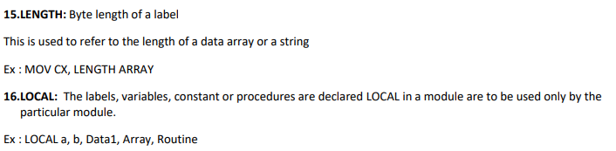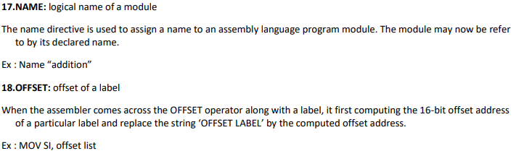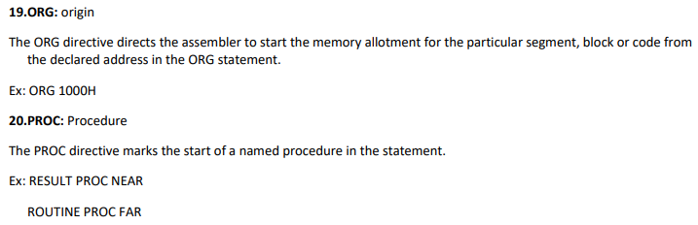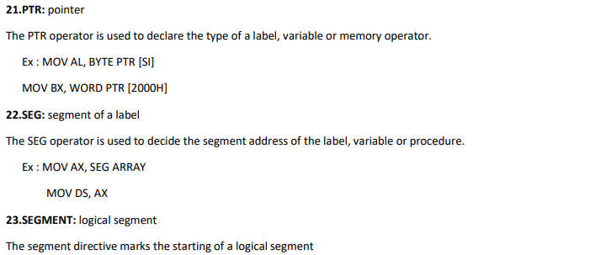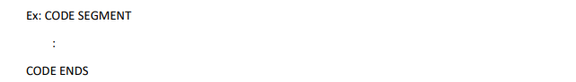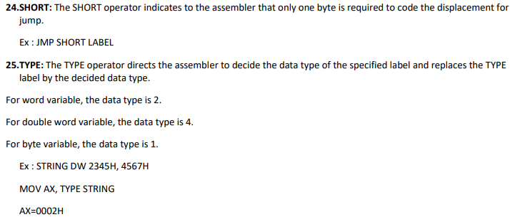

Programs
Addition
ORG0000h
MOV DX, #07H // move the value 7 to the register AX//
MOV AX, #09H // move the value 9 to accumulator AX//
Add AX, 00H // add CX value with R0 value and stores the result in AX//
END
Multiplication
ORG0000h
MOV DX, #04H // move the value 4 to the register DX//
MOV AX, #08H // move the value 8 to accumulator AX//
MUL AX, 06H // Multiplied result is stored in the Accumulator AX //
END
Subtraction
ORG 0000h
MOV DX, #02H // move the value 2 to register DX//
MOV AX, #08H // move the value 8 to accumulator AX//
SUBB AX, 09H // Result value is stored in the Accumulator A X//
END
Division
ORG 0000h
MOV DX, #08H // move the value 3 to register DX//
MOV AX, #19H // move the value 5 to accumulator AX//
DIV AX, 08H // final value is stored in the Accumulator AX //
END

